Redovisning/Inlämning(uppgift02)

Lösningar

App.php

<?php

class App

{

    public static $endpoint = "https://fakestoreapi.com/products";

    public static function main()

    {

        try {

            $array = self::getData();

            self::viewData($array);

        }

        catch (Exception $e) {

            echo $e->getMessage();

        }

    }

    public static function getData()

    {

        $json = @file_get_contents(self::$endpoint);

        // @ = Error Control Operator

        if (!$json)

            throw new Exception("Cannot access " . self::$endpoint);

        // Returnera data som en PHP-Array

        return json_decode($json, true);

    }

    public static function viewData($array)

    {

        $array1 = array_filter($array, function($item) {return $item['category'] == 'men clothing';});

        $array2 = array_filter($array, function($item) {return $item['category'] == 'women clothing';});

        $array3 = array_filter($array, function($item) {return $item['category'] == 'jewelery';});

        $array_final = array_merge($array1, $array2, $array3);

       $template = "";

       foreach ($array_final as $key => $value) {

         $template .= "

         <section>

            <div class='container'>

                <div class='row align-items-center'>

                    <div class='col-lg-6 order-lg-2'>

                        <div class='p-4'>

                            <img

                            src='$value[image]'

                            class='img-fluid rounded-circle'

                            alt=''

                            >

                        </div>

                    </div>

                    <div class='col-lg-6 order-lg-1'>

                        <div class='p-5'>

                            <h2 class=display-8>

                                $value[title]

                            </h2>

                            <p>

                                Price: $value[price]

                            </p>

                            <p> Description: $value[description]

                            </p>

                            <p> Category: $value[category]

                            </p>

                        </div>

                    </div>

                </div>

            </div>

        </section>

        <hr>";

      }

      echo $template;

    }

}

?>

Index.php

<?php include '../App.php'; ?>

<!DOCTYPE html>

<html lang="en">

<head>

  <meta charset="utf-8">

  <meta name="viewport" content="width=device-width, initial-scale=1, shrink-to-fit=no">

  <meta name="description" content="">

  <meta name="author" content="">

  <title>products</title>

  <!-- Bootstrap core CSS -->

  <link href="vendor/bootstrap/css/bootstrap.css" rel="stylesheet">

  <!-- Custom fonts for this template -->

  <link href="https://fonts.googleapis.com/css?family=Catamaran:100,200,300,400,500,600,700,800,900" rel="stylesheet">

  <link href="https://fonts.googleapis.com/css?family=Lato:100,100i,300,300i,400,400i,700,700i,900,900i" rel="stylesheet">

  <!-- Custom styles for this template -->

  <link href="css/one-page-wonder.css" rel="stylesheet">

</head>

<body>

  <header class="masthead text-center text-white">

    <div class="masthead-content">

      <div class="container">

        <h1 class="masthead-heading mb-0">Webbsida</h1>

        <h2 class="masthead-subheading mb-0">Welcome</h2>

      </div>

    </div>

    <div class="bg-circle-1 bg-circle"></div>

    <div class="bg-circle-2 bg-circle"></div>

    <div class="bg-circle-3 bg-circle"></div>

    <div class="bg-circle-4 bg-circle"></div>

  </header>

  <?php App::main(); ?>

  <!-- Footer -->

  <footer class="py-5 bg-black">

    <div class="container">

      <p class="m-0 text-center text-white small">Copyright &copy; Your Website 2020</p>

    </div>

    <!-- /.container -->

  </footer>

</body>

</html>

Skärmbilder

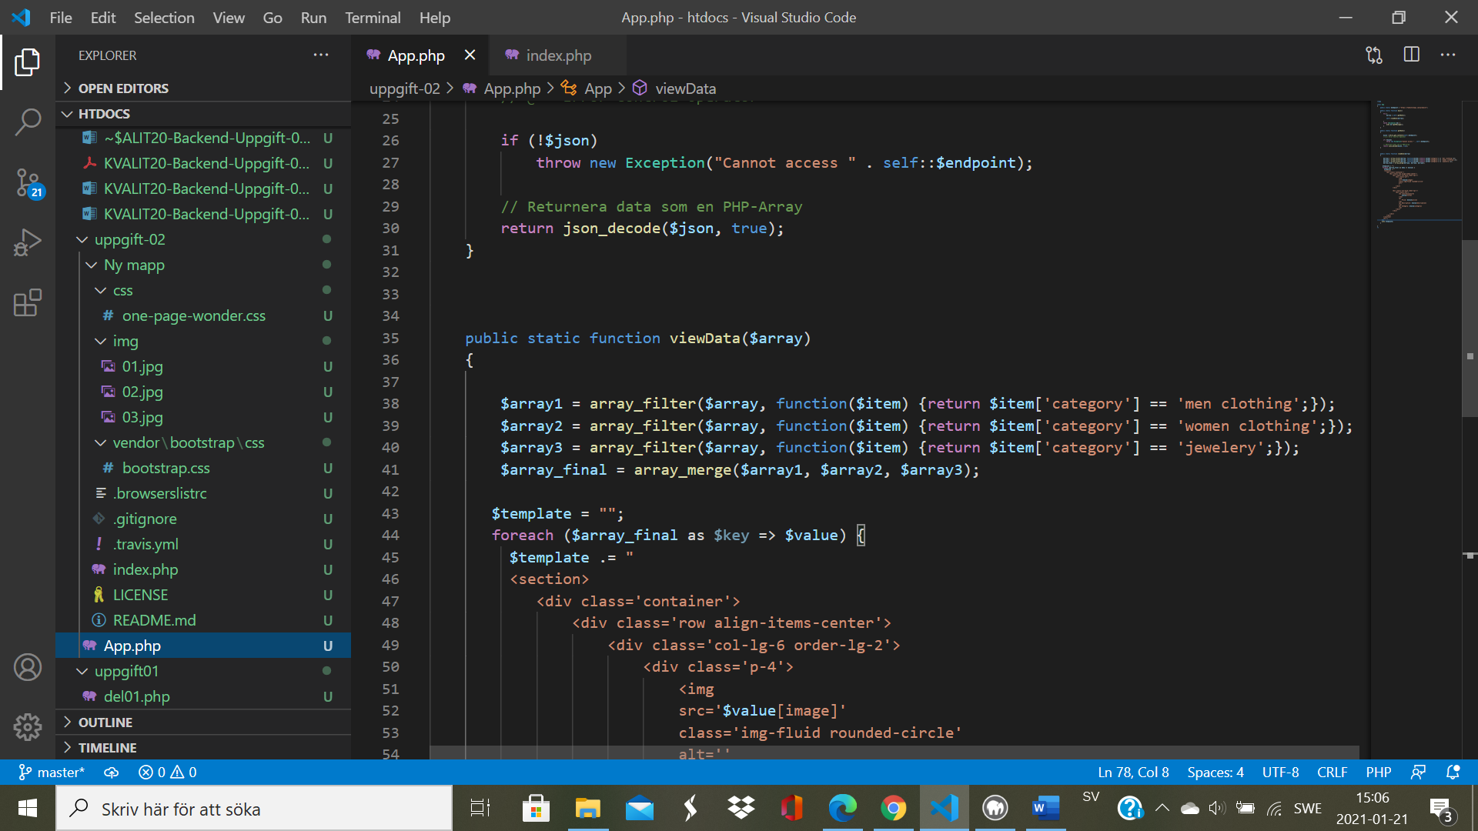

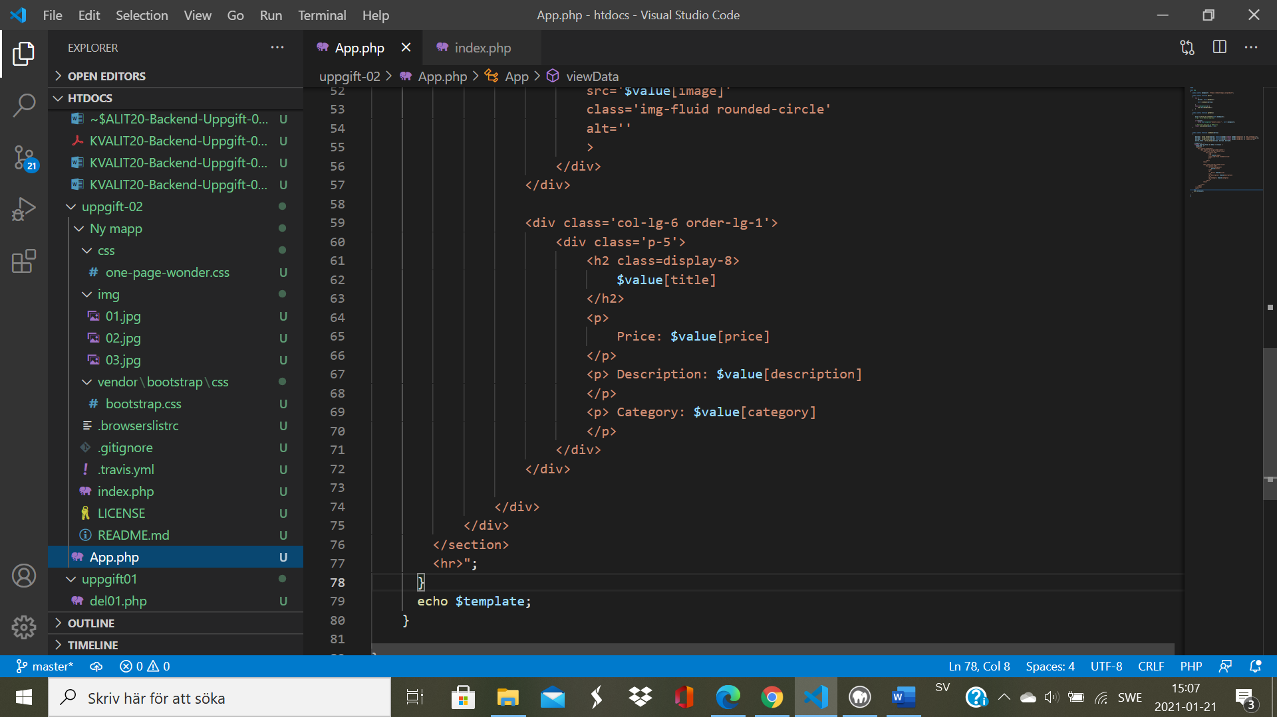

Reflektione

Svårt.Det behöver vara mycket försiktig och bra logisk. Och kurseb är snabb, så många kunskap förstås inte. Bara imiteta.